HW2 requirements Testing

Source code:

1-a. Add a feature to the expression parsing code

I added a feature to parse the strings into decimals

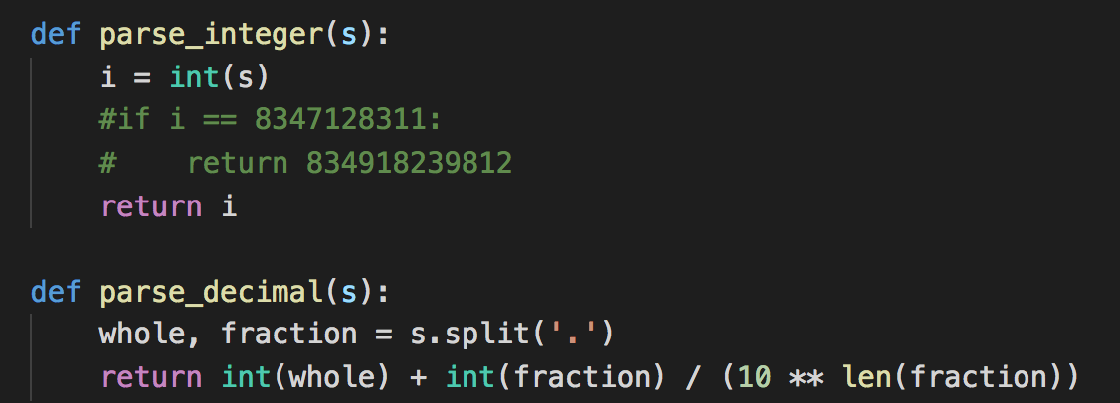

1-b. Add test case in the test_evaluate.py file

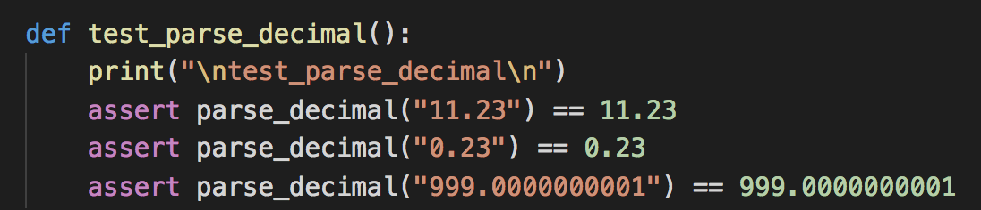

We can test the new feature using pytest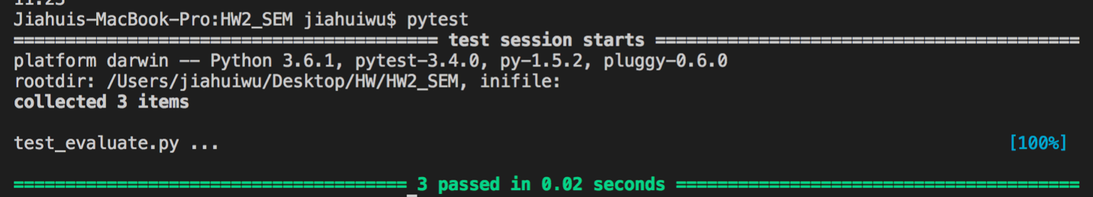

Or we call the function directly in the evaluate.py file to see if it can parse the string into decimal, they are the same

/Users/jiahuiwu/Desktop/pic/Screen Shot 2018-03-08 at 3.33.00 PM.png



2. Verify using requests and pytest that some API on this list works correctly:

<https://github.com/toddmotto/public-apis>

I chose two API to test, the first one is called TacoFancy <http://taco-randomizer.herokuapp.com/>, visiting this page will get users a random taco. I tested the connection, the headers content-type and keywords in the response text.

The second one is called LinkPreview, this API Get JSON formatted summary with title, description and preview image for any requested URL. I use this API to get the json data from the url <https://www.google.com>. The connection and header’s content-type was tested. The properties of the returned data such as ‘title’, ‘url’ are also tested.

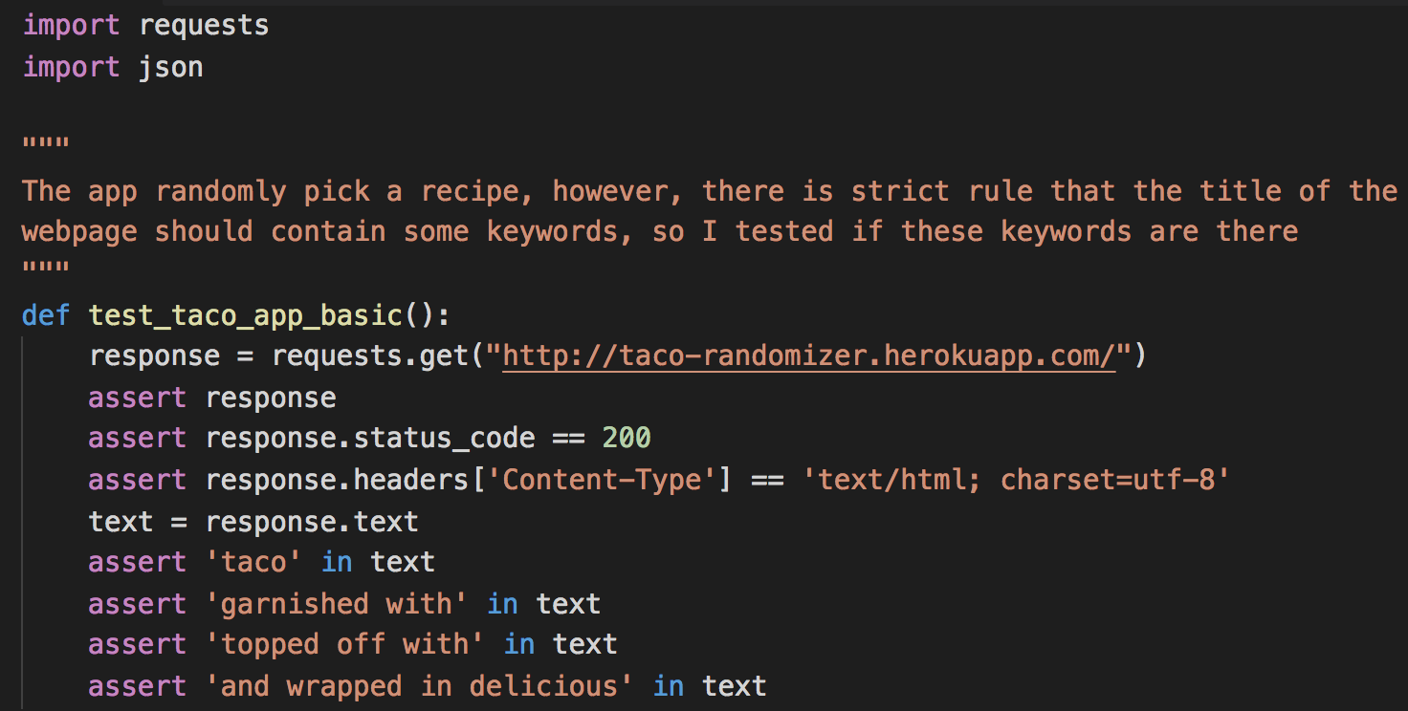

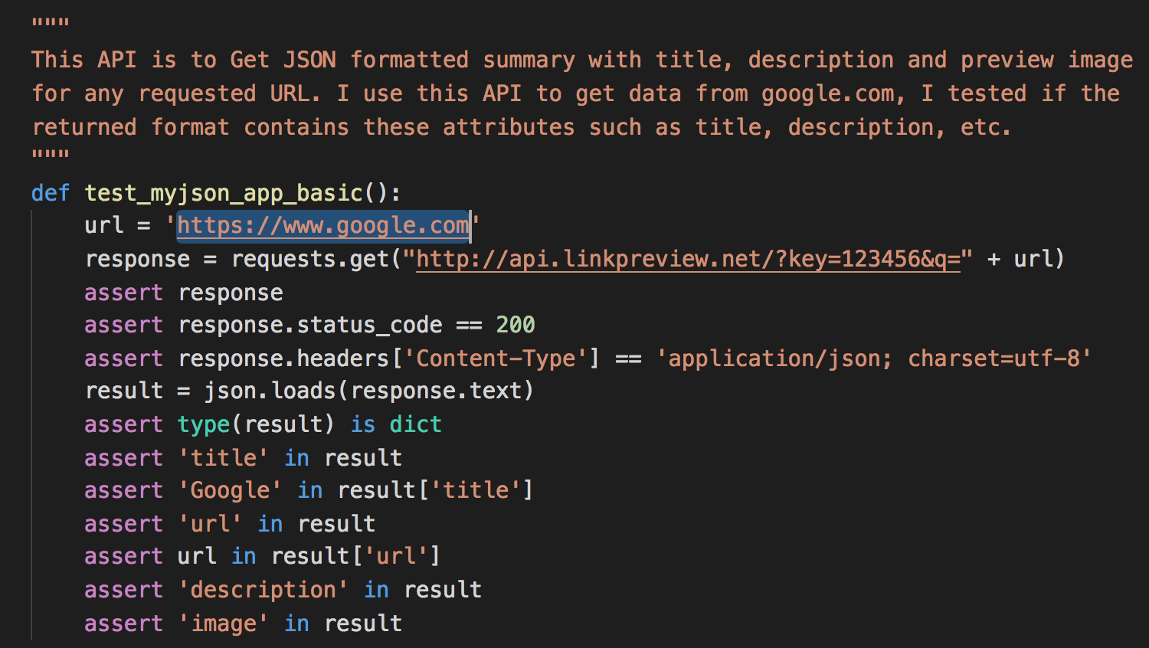

Result of the pytest, these two APIs are works correctly.

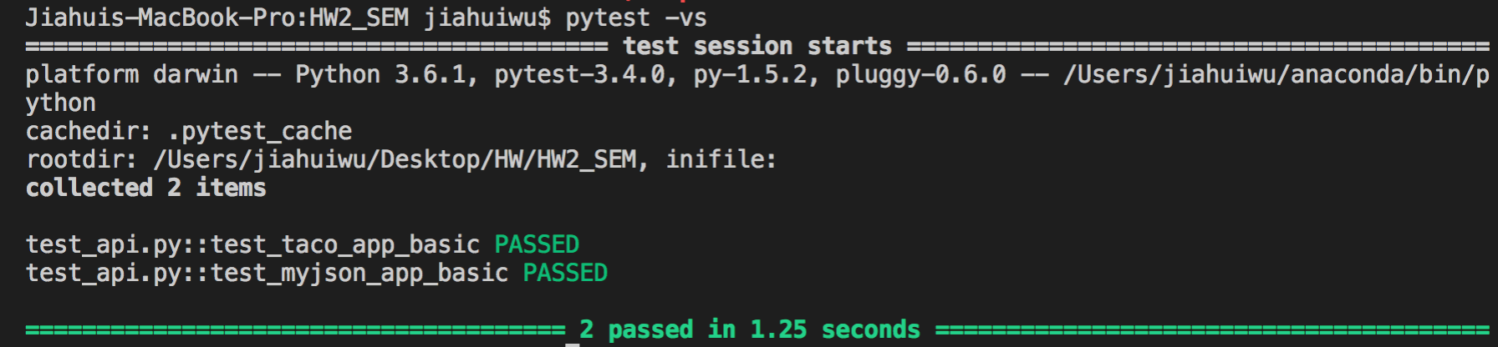

3. Verify using webdriver and pytest that either "Oster" or "Hamilton Beach" is one of the blenders brands sold on Amazon on the "blender" search page.

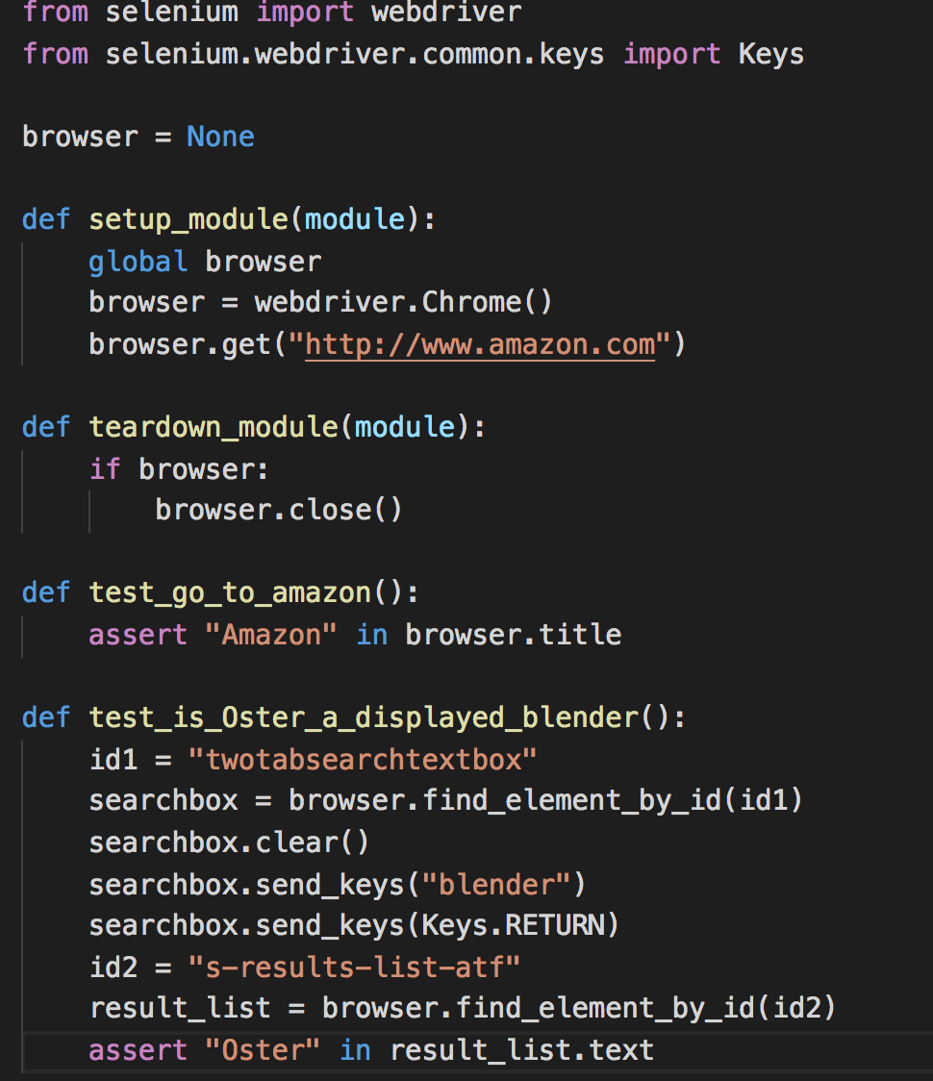

Test result shows that “Oster” is in the search result of blender on Amaozn

